Use Case Document
Common Mapping and Transformation Service

Owner: caAdapter Development Team
National Cancer Institute
Center for Biomedical Informatics and Information Technology
2115 East Jefferson Street
Rockville, MD 20852

 |   Center for Biomedical Informatics and Information Technology


DOCUMENT REVISION HISTORY
Version Number | Date | Description
1.0 | 31-Aug-09 | - Initial Draft
2.0 | 18-Aug-10 | - Expand to common mapping and transformation
3.0 | 01-June-11 | - Expand scope to support XSLT
3.1 | 15-Nov-11 | - Expand scope to support CDE, RDF and RESTfull service API

Background/Summary
This document contains the use cases for the caAdapter Common Mapping and Transformation Service model. This module will provide the following capabilities:
- Model and represent XSD as metadata of source or target data
- Implement XML data parser conform with XSD
- Connect to caBIG CDE browse online CDE information
- Map source metadata (XSD) to target metadata (XSD)
- Implement data processing functions
- Generate artifacts for XSLT compatible data transformation tools
- Generate artifacts for XQuery compatible data transformation tools
- Produce XML instances conformed to XSD definition
- Encode XML instances with RDF statements if required by XSD definition
- Provide APIs for programming integration
- Provide web service API and RESTfull service API for service integration
Table of Content
Background/Summary 3
1 Introduction 7
1.1 Overview 7
1.2 Related Documents 7
2 Actors and Goals 7
2.1 Systems Analyst 7
2.2 Application Developer 8
2.3 External System 8
3 Use Cases 8
3.1 Present Metadata of Source Data in the Mapping Source Panel 8
3.1.1 Use Case Model 8
3.1.2 Brief Description 8
3.1.3 Primary Actor 8
3.1.4 Preconditions 9
3.1.5 Basic Flow of Events 9
3.1.6 Alternative Flow 9
3.1.7 Post Conditions 9
3.1.8 Special Requirements 9
3.2 Present Metadata of Target Data in the Mapping Target Panel 10
3.2.1 Use Case Model 10
3.2.2 Brief Description 10
3.2.3 Primary Actor 10
3.2.4 Preconditions 10
3.2.5 Basic Flow of Events 10
3.2.6 Alternate Flow 10
3.2.7 Post Conditions 11
3.2.8 Special Requirements 11
3.3 Connect to CDE Browser from Metadata 12
3.3.1 Use Case Model 12
3.3.2 Brief Description 12
3.3.3 Primary Actor 12
3.3.4 Preconditions 12
3.3.5 Basic Flow of Events 12
3.3.6 Alternate Flow 13
3.3.7 Post Conditions 13
3.3.8 Special Requirements 13
3.4 Map Source Metadata to Target Metadata 14
3.4.1 Use Case Model 14
3.4.2 Brief Description 14
3.4.3 Primary Actor 14
3.4.4 Preconditions 14
3.4.5 Basic Flow of Events 14
3.4.6 Alternate Flow 15
3.4.7 Post Conditions 15
3.4.8 Special Requirements 15
3.5 Generate Integration Artifacts for Compatible Transformation Tools 16
3.5.1 Use Case Model 16
3.5.2 Brief Description 16
3.5.3 Primary Actor 16
3.5.4 Secondary Actor 16
3.5.5 Preconditions 16
3.5.6 Basic Flow of Events 16
3.5.7 Alternate Flow 17
3.5.8 Post Conditions 17
3.5.9 Special Requirements 17
3.6 Transform Source Dataset to Target Dataset 17
3.6.1 Use Case Model 18
3.6.2 Brief Description 18
3.6.3 Primary Actor 18
3.6.4 Secondary Actor 18
3.6.5 Preconditions 18
3.6.6 Basic Flow of Events 19
3.6.7 Alternate Flow 19
3.6.8 Post Conditions 19
3.6.9 Special Requirements 19
3.7 Transform with Programming APIs 20
3.7.1 Use Case Model 20
3.7.2 Brief Description 20
3.7.3 Primary Actor 20
3.7.4 Secondary Actor 20
3.7.5 Preconditions 21
3.7.6 Basic Flow of Events 21
3.7.7 Alternate Flow 21
3.7.8 Post Conditions 21
3.7.9 Special Requirements 21
3.8 Transform with Web Service APIs 22
3.8.1 Use Case Model 22
3.8.2 Brief Description 22
3.8.3 Primary Actor 22
3.8.4 Secondary Actor 23
3.8.5 Preconditions 23
3.8.6 Basic Flow of Events 23
3.8.7 Alternate Flow 23
3.8.8 Post Conditions 23
3.8.9 Special Requirements 24
3.9 Transform with RESTful Service APIs 24
3.9.1 Use Case Model 24
3.9.2 Brief Description 24
3.9.3 Primary Actor 25
3.9.4 Secondary Actor 25
3.9.5 Preconditions 25
3.9.6 Basic Flow of Events 25
3.9.7 Alternate Flow 25
3.9.8 Post Conditions 26
3.9.9 Special Requirements 26
3.10 Use Integration Artifacts for Compatible Transformation Tools 27
3.10.1 Use Case Model 27
3.10.2 Brief Description 27
3.10.3 Primary Actor 27
3.10.4 Secondary Actor 27
3.10.5 Preconditions 27
3.10.6 Basic Flow of Events 28
3.10.7 Alternate Flow 28
3.10.8 Post Conditions 28
3.10.9 Special Requirements 28
3.11 Access through Web Browser 29
3.11.1 Use Case Model 29
3.11.2 Brief Description 29
3.11.3 Primary Actor 29
3.11.4 Secondary Actor 29
3.11.5 Preconditions 29
3.11.6 Basic Flow of Events 29
3.11.7 Alternate Flow 30
3.11.8 Post Conditions 30
3.11.9 Special Requirements 30
4 Overall Requirements 31
5 Requirements Prioritization 31
6 Sign Off 32
6.1 Approval 32

Introduction

Overview
The National Cancer Institute Center for Biomedical Informatics and Information Technology (NCI CBIIT) developed caAdapter tool with the goal of creating standards-based infrastructure components to facilitate medical research data exchange. caAdapter is a open source tool kit including Model Mapping Service, HL7 Mapping and Transformation Service, and Global Model Exchange Service. caAdapter develops this Common Mapping and Transformation Service (CMTS) module to meet needs of users in the caBIG community for an easy-to-use tool to map and transform data among different kinds of data sources.
The CMTS will be developed on the basis of XML schema (XSD) specification. It defines metadata of source data format and target data format with XSD including structure, content , semantic representation of Common Data Element (CDE), and constraints of Resource Description Framework. Mapping engine creates links between nodes of source XSD and target XSD. XQuery generator produces integration artifacts for XQuery compatible data transformation tools. XSLT generator produces integration artifacts for XSLT compatible data transformation tools. Transformation engine converts source data into target data using mapping between source data metadata and target data metadata, data processing functions, CDE formatting rules, RDF encoding instructions, and XSD validation rules.
The CMTS module will extend caAdapter’s data mapping and transformation capabilities for data exchange. The effort for developing this module will leverage existing caAdapter capabilities, and applicable open source packages.
This Use Case Document captures the main use cases of CMTS module.

Related Documents
- Common Mapping and Transformation Service Scope Document

Actors and Goals
An actor is a person, organization, or external system that plays a role in one or more interaction with the Common Mapping and Transformation Service module. The following is a list of Actors that interact with this module:

Systems Analyst
This actor will use the CMTS module to map source data metadata with target data metadata. The user also is able to invoke transformation engine to convert a source dataset into target dataset using predefined mapping.

Application Developer
This actor is responsible for developing data processing system using the transformation capabilities of the CTMS module. The system may integrate with CMTS transformation engine through programming API to use it as a plug-in unit. It can also access CMTS transformation engine through web service API to use it as a service provider.

External System
This actor represents any External System that interacts with the CMTS module using programming API, web service API, RESTful service API, or web service access point.

Use Cases

Present Metadata of Source Data in the Mapping Source Panel

Use Case Model
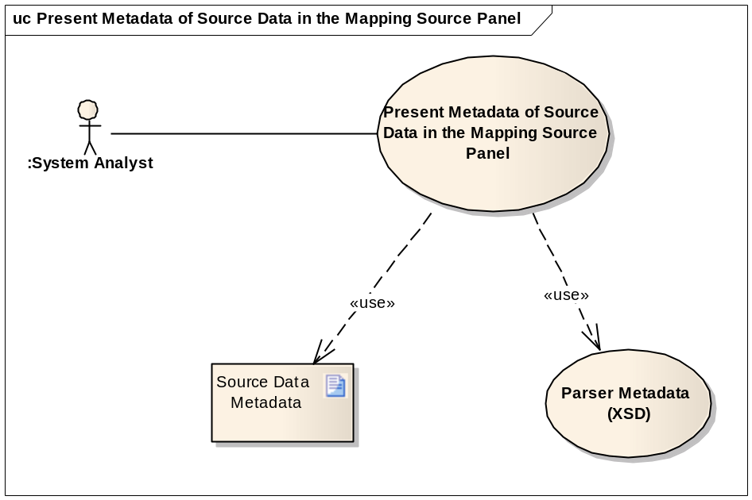

Brief Description
This use case covers reading the metadata of source data, and displaying it in the source panel of the mapping tool. The metadata is defined with XSD.

Primary Actor
Systems Analyst

Preconditions
- Metadata of source data is ready in the format of XSD

Basic Flow of Events
- User launches the CMTS module UI
- User selects a metadata file from the file system
- System automatically recognizes the type of the data structure represented in the metadata file identified by the Analyst
- The system validates the selected metadata file (Optional step).
- The system displays the metadata in a tree structure in the mapping source panel.

Alternative Flow
N/A

Post Conditions
Success Condition
- The system displays the metadata of source data the mapping source panel
Error Condition
- The system cannot recognize the metadata file. The system will display an error describing the issue, and provides the Analyst with possible solution(s).

Special Requirements
N/A

Present Metadata of Target Data in the Mapping Target Panel

Use Case Model
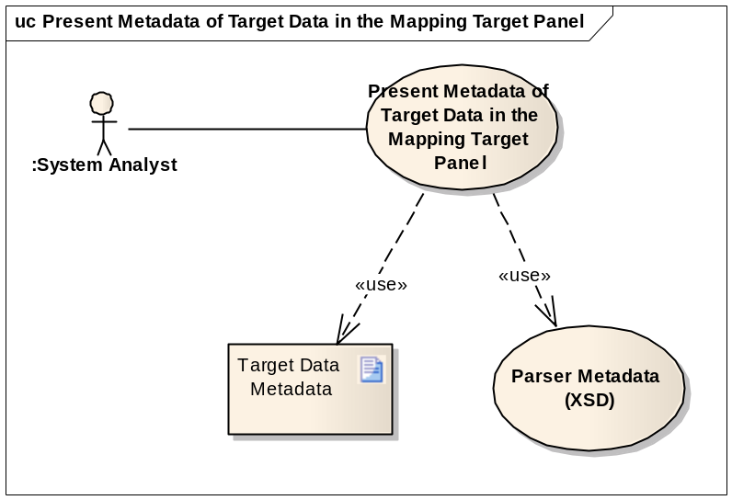

Brief Description
This use case covers reading the metadata of target data, and displaying it in the target panel of the mapping tool. The metadata is defined with XSD.

Primary Actor
Systems Analyst

Preconditions
- Metadata of target data is ready in the format of XSD

Basic Flow of Events
- User launches the CMTS module UI
- User selects a metadata file from the file system
- The system automatically recognizes the type of the data structure represented in the metadata file identified by the Analyst
- The system validates the selected metadata file (Optional step).
- The system displays the metadata in a tree structure in the mapping target panel

Alternate Flow
N/A

Post Conditions
Success Condition
- The system displays the metadata of target data in the mapping target panel
Error Condition
- The system is unable to recognize the metadata file. The system will display an error describing the issue, and providing the Analyst with possible solution(s)

Special Requirements
N/A

Connect to CDE Browser from Metadata

Use Case Model
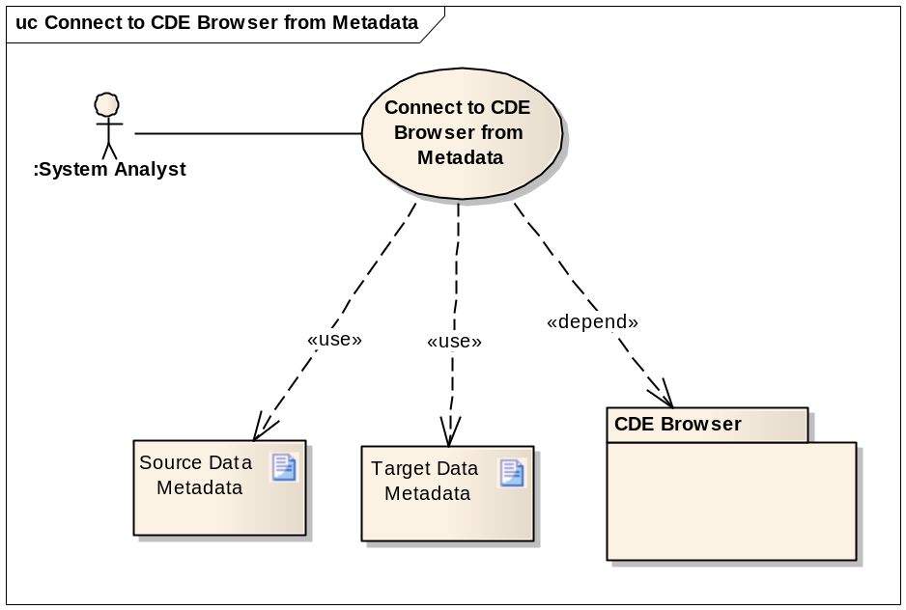

Brief Description
This use case covers browsing CDE information of a data element used in metadata (XSD) definition. It launches CDE browser from metadata (source or target) panel using CDE public ID. The use case depends on service of NCI CDE browser: https://cdebrowser.nci.nih.gov/CDEBrowser/.

Primary Actor
Systems Analyst

Preconditions
- Metadata of source or target data is ready in the format of XSD, which use CDE data element.
- NCI CDE browser is active

Basic Flow of Events
- User launches the CMTS module UI
- User selects a metadata (source or target) file from the file system
- The system automatically recognizes the type of the data structure represented in the metadata file identified by the Analyst
- The system validates the selected metadata file (Optional step).
- The system displays the metadata in a tree structure in a metadata panel
- User selects a node on the metadata tree
- System activates link to CDE browser if the selected node is defined with CDE public ID.
- User clicks link to CDE browser.
- System launches CDE browser in a new window displaying the CDE element with the public ID of the selected metadata node.

Alternate Flow
User launches CDE browser independently from CMTS using given CDE public ID. CDE browser would present the same information as being launched from CMTS UI.

Post Conditions
Success Condition
- The system displays the selected metadata and activates link to CDE browser
- CDE browser is successfully launched.
Error Condition
- The system is unable to recognize the metadata file, or
- CMTS UI activates link to CDE browser (s), but the CDE browser is not in service.

Special Requirements
CDE browser is deployed with updated resources.

Map Source Metadata to Target Metadata

Use Case Model
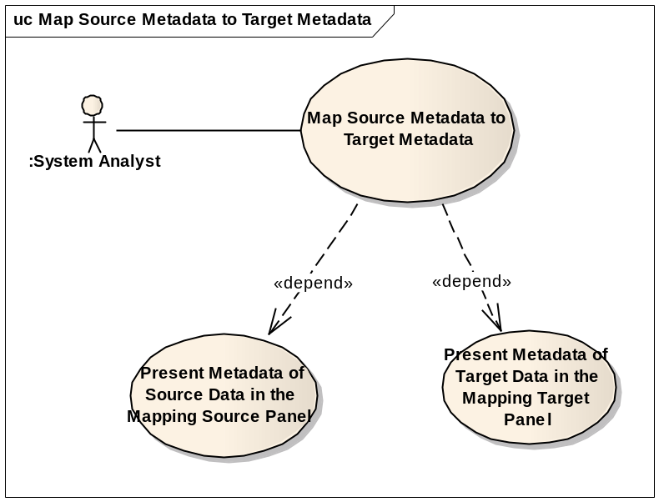

Brief Description
This use case covers the mapping activities from the source metadata to the target metadata. It creates mapping for data transformation engine to convert source data into target data and for code generation engine to generate integration artifacts of XQuery and XSLT.
This use case depends on success of two other use cases: Present Metadata of Source Data in the Mapping Source Panel; Present Metadata of Target Data in the Mapping Target Panel.

Primary Actor
Systems Analyst

Preconditions
- Source metadata is ready in the format of XSD.
- Target metadata is ready in the format of XSD.

Basic Flow of Events
            - User launches the CMTS module UI
            - User selects and open source metadata (XSD)
            - System presents source metadata on mapping source panel
            - User selects and open target metadata (XSD)
            - System presents target metadata on mapping target panel
            - User selects a source metadata node by clicking on it and dragging it over a target metadata node
            - System validates the mapping from source node to target node
            - User maps one or many source metadata node(s) to the input port(s) of data processing function(s); then maps the output port to a target metadata node. The functions will be used during data transformation
            - User deletes mapping links. System provides confirmation before executes a delete operation
            - Use saves the mapping into a file

Alternate Flow
  - User opens a mapping file saved earlier
  - The next steps in this flow are identical to steps 6 through 10 above

Post Conditions
Mapping file is saved for future use
Success Conditions
- Mappings are validated correctly according to identified validation rules
- A saved mapping file could be updated by user at a later time
Error Conditions
- System fails to create a mapping link and generates an error message explaining the problem, and advising user of possible solutions.
- System fails to open a saved mapping file because:
  - The source metadata file was modified since the last time the mapping file was saved
  - The target metadata file was modified since the last time the mapping file was saved

Special Requirements
The map file must be a text file to support system compatibility.

Generate Integration Artifacts for Compatible Transformation Tools

Use Case Model
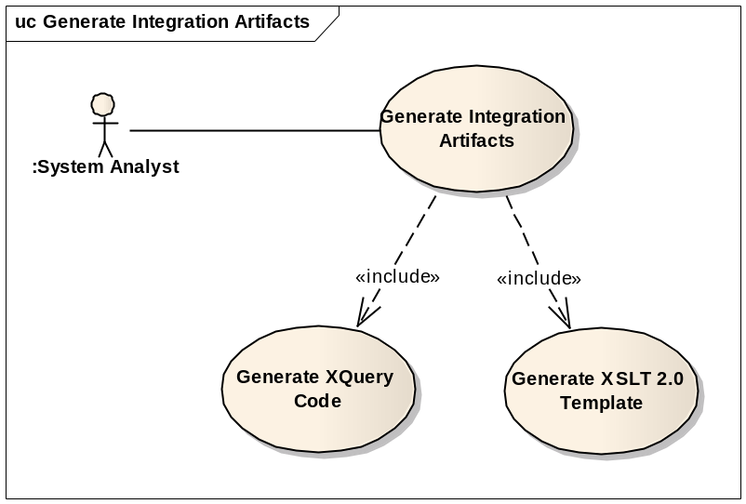

Brief Description
This use case covers generating integration artifacts for other compatible data transformation tools.
This use case uses two child use cases: Generate XQuery Code and Generate XSLT template.

Primary Actor
System Analyst

Secondary Actor
N/A

Preconditions
User has completed mapping which is saved as a file or run in system cache, along with source metadata and target metadata files

Basic Flow of Events
- User creates completed mapping using source metadata and target metadata. The mapping may or may not use data processing functions.
- User validates mapping against predefined mapping rules.
- User selects “Generate Integration Artifacts” action.
- User chooses type of integration artifacts: XQuery or XSLT.
- System promotes users to locate destination of the generated integration artifact.
- User sets file name for the generated artifact and launch “Generate” action.
- If the developer does not have an account on the Portal, She or he must be able to use the Portal to obtain one immediately by registering
- System generates and saves the integration artifact (XQuery or XSLT) into a separated file.

Alternate Flow
- User may select an existing mapping file at step 1.
- User proceeds step 2 to 8.

Post Conditions
Success Conditions
- Integration artifact is successfully generated and saved.
Error Conditions
- Fail to validate a mapping
- Fail to generate integration artifact.

Special Requirements
N/A

Transform Source Dataset to Target Dataset

Use Case Model
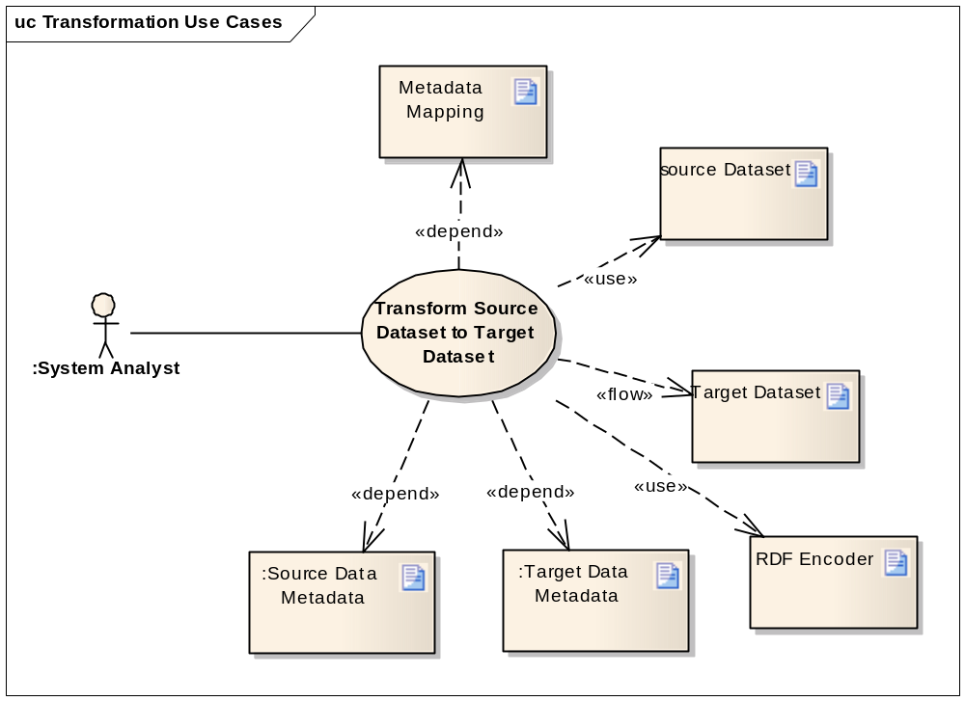

Brief Description
This use case covers the activities involved in transforming source dataset to target dataset using the predefined mapping along with associated source metadata and target metadata.

Primary Actor
Systems Analyst

Secondary Actor
N/A

Preconditions
- Mapping between the source metadata and target metadata has been completed
- A valid mapping file was created

Basic Flow of Events
- User selects opens a mapping file using CMTS UI, then selects the data transformation option
- System promotes user to specify source dataset(s) file, and name and location of target dataset file
- System process mapping file along with the associated source metadata file and target metadata file.
- System generates target dataset using source data and mapping.

Alternate Flow
- After step 4 of Basic Flow of Events, RDF encoder processes the generated target data set and encodes it with RDF constraints and statements.

Post Conditions
Success Conditions
- System creates the target dataset compliant with the target metadata, optionally conformed with caBIG semantic interoperability standard and RDF encoding rules.
Error Conditions
- Fail to process mapping or source dataset
- Fail to generate target dataset

Special Requirements
N/A

Transform with Programming APIs

Use Case Model
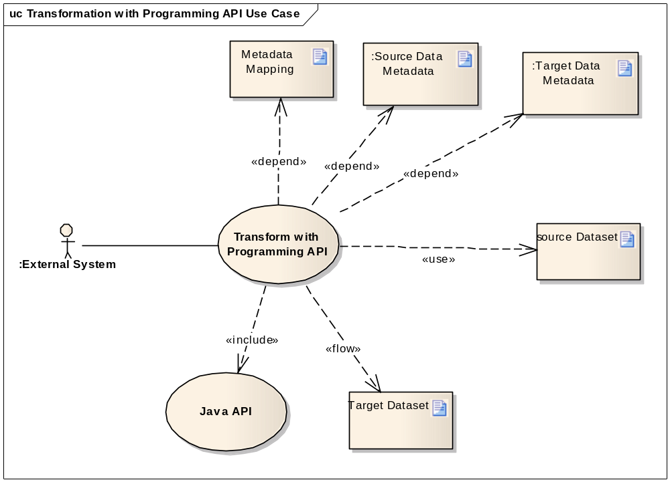

Brief Description
This use case covers the activities involved in integrating CMTS module with an external information processing system as plug-in. The external system accesses CMTS transformation engine though programming API.
The transformation engine transforms source dataset to target dataset using the predefined mapping along with associated source metadata and target metadata. It optionally applies caBIG semantic interoperability standard and RDF encoding rules if it is required in the definition of target metadata (XSD).

Primary Actor
External System

Secondary Actor
N/A

Preconditions
- Mapping between the source metadata and target metadata has been completed
- A valid mapping file was created

Basic Flow of Events
- User starts data transformation step
- User processes mapping file, source metadata file, target metadata file, and source dataset file
- User invokes CMTS transformation engine locally through programming API
- CMTS transformation engine processes mapping file along with associated source metadata and target metadata
- CMTS transformation engine generates target data using source data and mapping

Alternate Flow
N/A

Post Conditions
Success Conditions
- Successfully creates the target dataset compliant with the target metadata
Error Conditions
- Fail to process mapping or source dataset
- Fail to generate target dataset

Special Requirements
N/A

Transform with Web Service APIs

Use Case Model
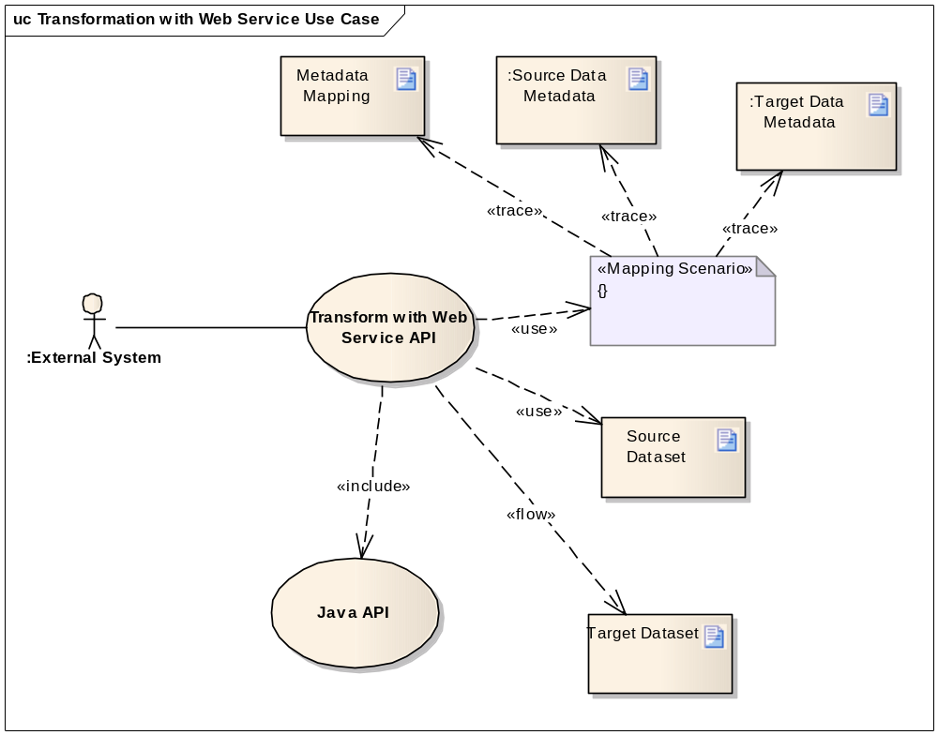

Brief Description
This use case covers the activities involved in integrating an external information processing system with the web service (SOAP) access point of CMTS module. The web service server instantiates CMTS transformation engine and performs data transformation of user’s data remotely. One CMTS web service server will support multiple users (client systems).
This use case is a variation of “Transform with Programming API”. The similar functionalities are performed remotely including data processing functions, CDE semantic interoperability, and RDF encoding .

Primary Actor
External System

Secondary Actor
Application Developer

Preconditions
- Mapping between the source metadata and target metadata has been completed
- A valid mapping file was created.
- CMTS web service was setup

Basic Flow of Events
- User starts data transformation step
- User register mapping scenario on server and upload mapping file along associated source metadata and target metadata.
- User invokes CMTS transformation engine remotely, which is deployed on over service server, with mapping scenario identifier and source data.
- The remote service server retrieves pre-registered mapping and associated source metadata and target metadata using given scenario identifier.
- The remote service server invokes transformation engine to generate target data and mapping.
- The remote service server returns target data to user (client program).

Alternate Flow
N/A

Post Conditions
Success Conditions
- Web service server successfully creates the target dataset compliant with the target metadata
- User (client program) successfully retrieved target dataset from web service server.
Error Conditions
- Web service server failed to process mapping or source dataset
- Web service server failed to generate target dataset
- User(client program) failed to retrieve target dataset from web service server

Special Requirements
N/A

Transform with RESTful Service APIs

Use Case Model
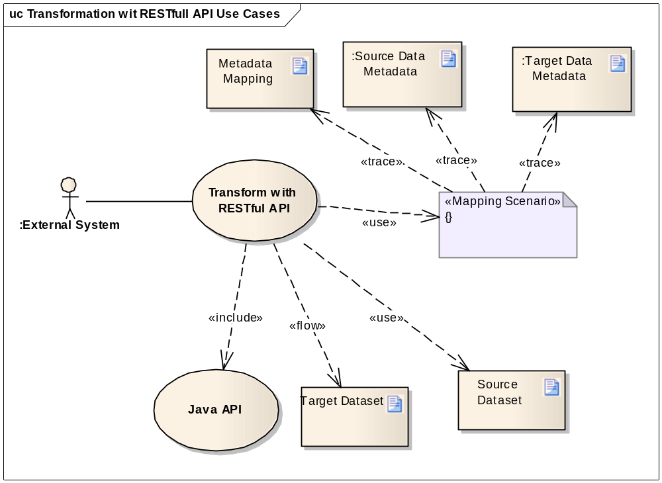

Brief Description
This use case covers the activities involved in integrating an external information processing system with the RESTful service server of CMTS module. The RESTful service server instantiates CMTS transformation engine and performs data transformation of user’s data remotely. One RESTful service server will support multiple users (client systems).
This use case is a variation of “Transform with Programming API”. The similar functionalities are performed remotely including data processing functions, CDE semantic interoperability, and RDF encoding .

Primary Actor
External System

Secondary Actor
Application Developer, Web Browser

Preconditions
- Mapping between the source metadata and target metadata has been completed
- A valid mapping file was created.
- CMTS web service was setup

Basic Flow of Events
- User starts data transformation step
- User register mapping scenario on server and upload mapping file along associated source metadata and target metadata.
- User invokes CMTS transformation engine remotely, which is deployed on over service server, with mapping scenario identifier and source data.
- The remote service server retrieves pre-registered mapping and associated source metadata and target metadata using given scenario identifier.
- The remote service server invokes transformation engine to generate target data and mapping.
- The remote service server returns target data to user (client program).

Alternate Flow
If user access RESTful service server through a web browser after step 3, flow of events are following:
- User launch web browser
- User enter RESTfull service server URL and parameters
- Web browser sends HTTP request to CMTS RESTfull server
- Remote RESTful server retrieves pre-registered mapping and associated source metadata and target metadata using given scenario identifier.
- The remote RESTful server invokes transformation engine to generate target data and mapping.
- The remote RESTful server set target data with HTTP response.
- Web browser processes HTTP response and present target data to user.

Post Conditions
Success Conditions
- RESTful service server successfully creates the target dataset compliant with the target metadata
- Web browser successfully retrieved target dataset from RESTful server and presented it to user.
Error Conditions
- RESTful service server failed to process mapping or source dataset
- RESTful service server failed to generate target dataset
- Web browser failed to retrieve target dataset from RESTful service server

Special Requirements
N/A

Use Integration Artifacts for Compatible Transformation Tools

Use Case Model
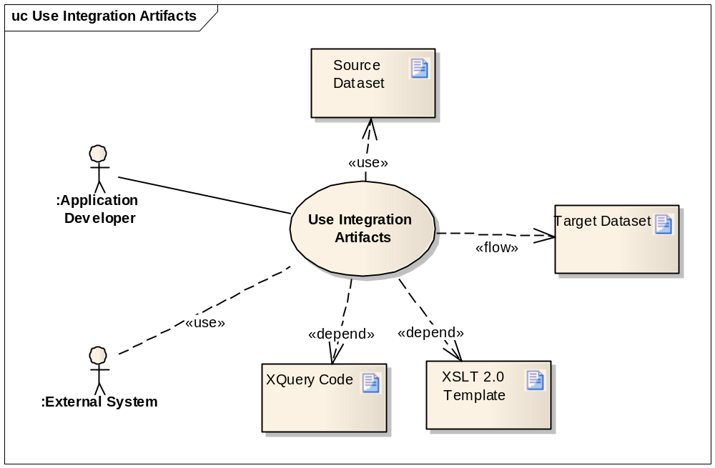

Brief Description
This use case covers the activities involved in transforming source dataset to target dataset using other compatible data transformation tools. The primary user develops an information processing system using CMTS to generate integration artifacts (in XQuery format or XSLST format) and available data transformation tools to create target dataset.
Alternatively, the second user may obtain the integration artifacts with other mapping tools and invoke the CMTS transformation API to convert source dataset to target dataset using the integration artifacts.

Primary Actor
Application Developer

Secondary Actor
External System

Preconditions
- The integration artifacts are generated in the format of XQuery if the transformation tools are compatible with XQuery.
- The integration artifacts are generated in the format of XSLT template if the transformation tools are compatible with XSLT.

Basic Flow of Events
- User generates integration artifacts following steps defined in use case 3.4: Generate Integration Artifacts for Compatible Transformation Tools.
- User implements integration program to access the transformation APIs of compatible tools.
- User forwards the integration artifacts generated in step 1 to the integration process.
- The compatible transformation tools generate target dataset using source dataset and integration artifacts.

Alternate Flow
At step 2, user can launch UI to invoke transformation functionalities if the transformation tools provide operation UI.

Post Conditions
Success Conditions
- The compatible transformation tools successfully generate target dataset from source dataset using the integration artifacts generated by CMTS.
Error Conditions
- The compatible tools fail in processing the integration artifacts generated by CMTS.

Special Requirements
N/A

Access through Web Browser

Use Case Model
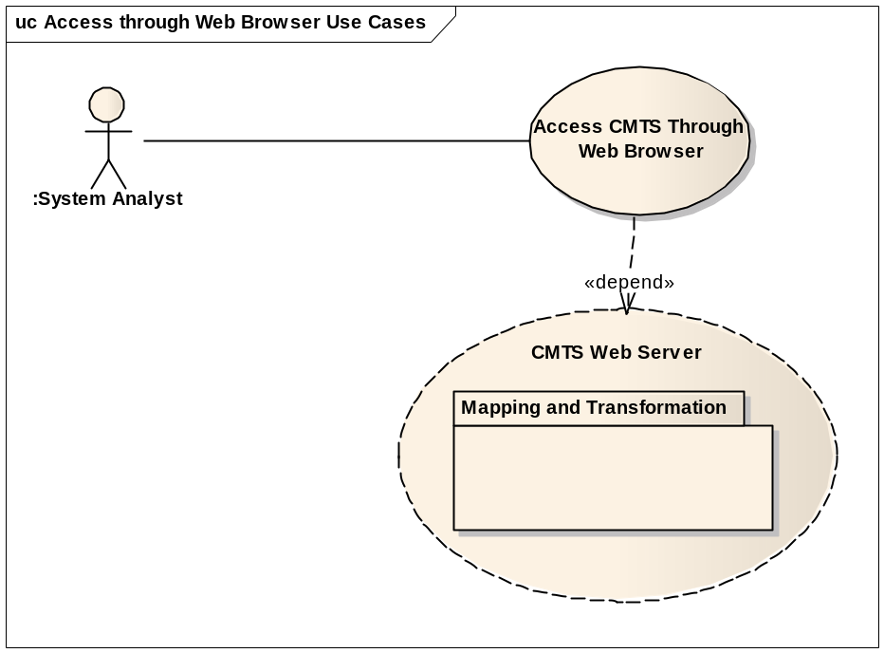

Brief Description
This use case covers the requirements to access the mapping and transformation functionalities through web browser such as Internet Explorer, FireFox, etc. The CMTS module implements web access API presenting its rich graphical features. Through web browser, user will be able to perform the full scope of operations in mapping and transformation.

Primary Actor
System Analyst

Secondary Actor
N/A

Preconditions
- The CMTS web server is deployed and ready to process client request.

Basic Flow of Events
- User launches web browser on client site
- The browser connects to CMTS site.
- CMTS web server delivers the application to client’s browser
- User creates mapping between a source metadata and a target metadata
- User performs other operations such as Generate Integration Artifacts for Compatible Transformation Tools, Transform Source Dataset to Target Dataset, etc.

Alternate Flow
At step 4, user can open an existing mapping, and then perform other operations.

Post Conditions
Success Conditions
- User successfully access CMTS web server and perform operations of mapping and transformation
Error Conditions
- Fail to access CMTS web server
- Fail to perform operations of mapping and transformation

Special Requirements
N/A

Overall Requirements
See CMTS Module Requirements.

Requirements Prioritization
Priority | Use Case Name | Supp Requirement Ref #

Sign Off

Approval

Workspace General Contractor Rep Print Name Date
Architecture Workspace Rep Print Name Date
VCDE Workspace Rep Print Name Date
Workspace Working Group Rep Print Name Date
NCICB Rep Print Name Date

